**INTRODUCTION**

The Memory Puzzle Game is a cognitive skill-building game designed to improve memory, concentration, and mental flexibility through engaging, interactive gameplay. At its core, the game revolves around the concept of memory matching, where players are presented with a set of cards or tiles, each hiding a unique image or object. The objective is to flip over the cards to reveal matching pairs, testing the player’s ability to remember the location of each image and match them correctly.

Memory puzzles have long been recognized for their educational and therapeutic benefits, as they stimulate the brain's short-term memory and enhance cognitive functions such as attention, pattern recognition, and spatial awareness. The Memory Puzzle Game taps into these benefits, providing an enjoyable and interactive way to exercise the mind. The game's simplicity makes it easy to understand, but the variety of challenges it offers keeps it engaging for players of all ages.

In the context of its design, the Memory Puzzle Game can be played in various settings, including educational environments, recreational activities, and as part of cognitive training for adults looking to maintain or improve their mental faculties. The game’s user-friendly interface, colorful visuals, and adaptive difficulty levels allow it to be accessible for a wide demographic, from young children learning basic memory skills to adults seeking mental stimulation or therapy for cognitive conditions like dementia.

**PROJECT REQUIREMENT**

Developing a Memory Puzzle Game requires careful consideration of both technical and functional aspects to ensure that it is engaging, intuitive, and effective at enhancing memory and cognitive skills. Below are the key project requirements categorized into functional, technical, and non-functional specifications.

### 1. Functional Requirements

These describe the core features and functionalities the game must include:

* **User Interface (UI):**
  + Simple, clean, and intuitive design for easy navigation.
  + Visual and auditory cues for game actions (e.g., card flips, matches).
  + Option to choose game difficulty (e.g., number of cards, complexity of images).
  + Clear instructions on how to play and game rules.
* **Gameplay Mechanics:**
  + A grid-based system with hidden tiles or cards.
  + Players can flip over two cards at a time to reveal the hidden images.
  + Cards must remain face-up when matched and face-down when unmatched.
  + Timer to measure the time taken to complete a puzzle (optional).
  + Ability to reset or restart the game at any time.
  + Score tracking based on time taken or number of attempts.
* **Levels & Difficulty:**
  + Multiple levels with increasing difficulty (e.g., increasing the number of cards or complexity of images).
  + Option to select difficulty at the start (easy, medium, hard).
  + Adaptive difficulty to automatically adjust based on player performance (optional).
* **Game Modes:**
  + Single-player mode: The player plays against the clock or tries to complete the puzzle in the fewest moves.
  + Multiplayer mode (optional): Players can compete to finish the puzzle faster or with fewer attempts.
  + Challenge mode: Players must match images under time pressure or with a limited number of moves.
* **Progression and Rewards:**
  + Option to save game progress.
  + Reward system (e.g., points, stars, or unlockable levels) to motivate players.
  + Visual progress indicators (e.g., score, level, or time taken).
* **Sound and Visual Effects:**
  + Background music and sound effects for actions like card flips, matches, and incorrect attempts.
  + Visual animations for card flipping and matching pairs.
  + Visual feedback for correct and incorrect actions (e.g., green check for matches, red X for mismatches).

### 2. Technical Requirements

These define the technical specifications and technologies needed to implement the game:

* **Platform Compatibility:**
  + The game should be developed for multiple platforms, such as:
    - Mobile devices (iOS and Android)
    - Desktop/web browser (HTML5, JavaScript, CSS)
    - (Optional) Physical card-based game design.
* **Programming Languages and Frameworks:**
  + For mobile applications:
    - iOS: Swift or Objective-C
    - Android: Kotlin or Java
  + For web applications:
    - Frontend: HTML5, CSS, JavaScript, React, or Vue.js
    - Backend (if needed): Node.js or PHP for user authentication, score tracking, etc.
* **Game Engine (for digital versions):**
  + For more complex visual effects or animation, a game engine like Unity or Godot can be used, but this may not be necessary for simpler versions.
* **Data Storage and Persistence:**
  + For saving player scores and game progress, a local database or cloud-based storage (Firebase, SQLite) can be used.
  + Option for cloud storage or player login for tracking high scores, achievements, or game history.
* **User Authentication (optional):**
  + Player profiles with options for login (email, social media, etc.) for progress saving across devices.
* **Image and Audio Assets:**
  + High-quality, attractive, and diverse image assets for the cards (e.g., animals, objects, or themed categories).
  + Background music and sound effects (either royalty-free or custom-made).

### 3. Non-Functional Requirements

These address aspects that affect the quality and performance of the game:

* **Performance:**
  + Smooth and responsive gameplay with minimal loading time and lag.
  + Quick card flips and animations without delays.
* **Scalability:**
  + The game should be able to handle increasing difficulty levels or larger grids without a performance drop.
  + Scalable across different screen sizes and resolutions (responsive design for mobile and web).
* **Usability:**
  + The game should be easy to learn and accessible to players of all ages, with simple, straightforward controls.
  + Accessibility features for players with disabilities (e.g., color contrast, text-to-speech options, etc.).
* **Security:**
  + If user data is collected (e.g., for multiplayer mode or high scores), ensure that data is stored securely and follow privacy regulations.
* **Cross-Platform Compatibility:**
  + Ensure the game runs smoothly on both iOS/Android devices and desktop browsers.
* **Localization (Optional):**
  + Support for multiple languages, especially if the game is targeted at a global audience.

### 4. Development Tools and Resources

* **Design Tools:**
  + Graphics and asset design using tools like Adobe Photoshop, Illustrator, or Sketch for images and UI components.
  + Animation tools like Spine or After Effects for card flip and matching animations.
* **Code Repositories:**
  + Git or GitHub for version control and collaboration.
* **Testing Framework:**
  + Automated testing frameworks like Jest for unit tests (for web applications).
  + Manual testing for usability and gameplay experience.

### 5. Project Timeline & Milestones

A structured timeline to ensure timely delivery of the project:

* **Phase 1: Planning and Design** (2–3 weeks)
  + Game concept development
  + Storyboarding and wireframing
  + Asset creation and selection
* **Phase 2: Core Development** (4–6 weeks)
  + Implement core gameplay mechanics
  + Design and develop the user interface
  + Integrate difficulty levels and gameplay modes
* **Phase 3: Testing & Quality Assurance** (2–3 weeks)
  + Bug testing and fixing
  + Usability testing and feedback collection
* **Phase 4: Launch and Post-Launch** (1–2 weeks)
  + Prepare for launch on app stores/web deployment
  + Monitor user feedback for improvements and bug fixes

### 6. Future Enhancements (Optional)

* **Additional Game Modes:** Add more creative or challenging modes, such as time-based challenges, themed puzzles, or daily/weekly challenges.
* **AI Opponents:** In multiplayer mode, include AI players with adjustable difficulty levels.
* **Multilingual Support:** Add translations for different languages to broaden the game's reach.
* **Analytics Integration:** Track player behavior and performance for further gameplay refinement.

**UML DIAGRAM**

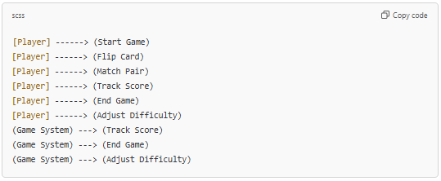

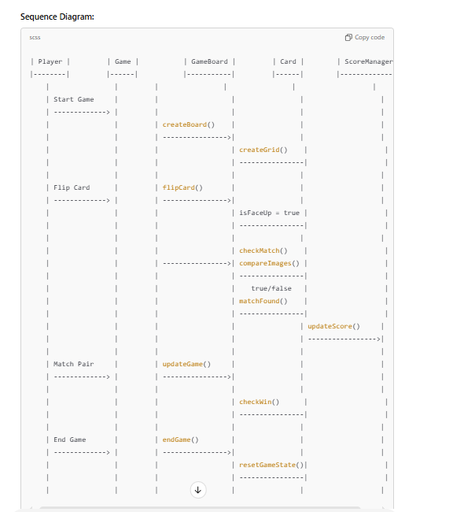

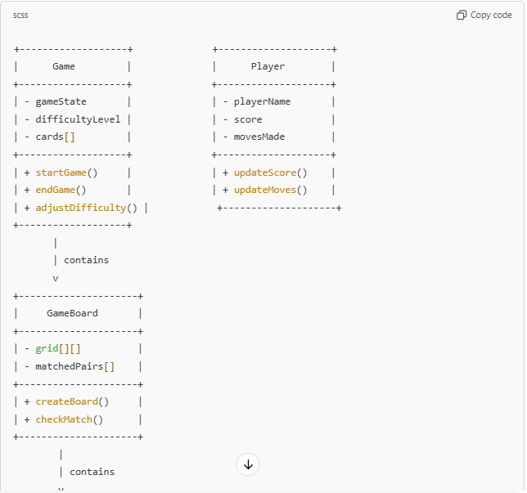

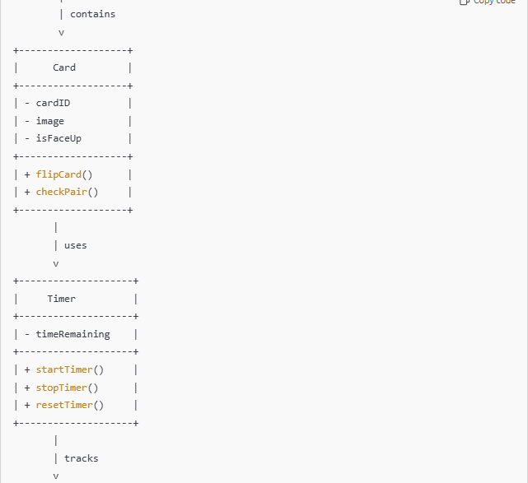

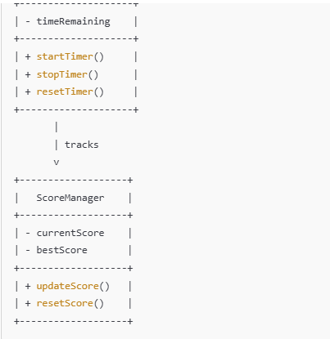

**SOURCE CODE**

import java.util.Scanner;

import java.util.Arrays;

import java.util.Random;

public class MemoryPuzzleGame {

public static void main(String[] args) {

Scanner scanner = new Scanner(System.in);

Random random = new Random();

// Grid size and time to memorize

final int gridSize = 4;

final int timeToMemorize = 5; // seconds

// Generate a random grid

int[][] grid = new int[gridSize][gridSize];

for (int i = 0; i < gridSize; i++) {

for (int j = 0; j < gridSize; j++) {

grid[i][j] = random.nextInt(100); // Random numbers between 0-99

}

}

// Display the grid for the player to memorize

System.out.println("Memorize this grid:");

for (int[] row : grid) {

System.out.println(Arrays.toString(row));

}

try {

Thread.sleep(timeToMemorize * 1000); // Pause for memorization

} catch (InterruptedException e) {

System.out.println("Error: " + e.getMessage());

}

// Clear the screen (simulate by printing blank lines)

System.out.println("\n".repeat(50));

System.out.println("Now, recall the grid!");

// Input the grid from the player

int[][] playerGrid = new int[gridSize][gridSize];

for (int i = 0; i < gridSize; i++) {

System.out.println("Enter row " + (i + 1) + " (space-separated numbers):");

for (int j = 0; j < gridSize; j++) {

playerGrid[i][j] = scanner.nextInt();

}

}

// Check the answers

int score = 0;

for (int i = 0; i < gridSize; i++) {

for (int j = 0; j < gridSize; j++) {

if (grid[i][j] == playerGrid[i][j]) {

score++;

}

}

}

// Display the results

System.out.println("\nOriginal Grid:");

for (int[] row : grid) {

System.out.println(Arrays.toString(row));

}

System.out.println("\nYour Input:");

for (int[] row : playerGrid) {

System.out.println(Arrays.toString(row));

}

System.out.println("\nYour Score: " + score + "/" + (gridSize * gridSize));

if (score == gridSize * gridSize) {

System.out.println("Excellent memory!");

} else if (score > (gridSize * gridSize) / 2) {

System.out.println("Good job, keep practicing!");

} else {

System.out.println("Better luck next time!");

}

scanner.close();

}

}

**EXPLANATION OF CODE**

The **Memory Puzzle Game** is a Java program that tests the player's ability to memorize and recall a grid of random numbers. Here's a concise explanation:

**Setup and Constants:**

* Defines gridSize (4x4 grid) and timeToMemorize (5 seconds to view the grid).
* Uses a Random object to generate random integers between 0 and

**CONCLUSION**

The **Memory Puzzle Game** is a fun and engaging way to test and enhance memory skills. By challenging players to recall a grid of random numbers after a brief memorization period, the game encourages focus, concentration, and short-term memory development.

The scoring system provides clear feedback on performance, with messages tailored to motivate players regardless of their score:

* **Perfect Score:** Recognized as having excellent memory.
* **Above Average:** Encouraged to keep practicing and improve further.
* **Low Score:** Prompted to try again for better results.

This game blends entertainment with cognitive exercise, making it a simple yet effective tool for mental sharpening and self-improvement.